**History of Hobby Horsing 08/01/2026 - Elina "Elli" Virtanen, Copyright © 2026 Hobby Horse Hub**

**https://hobbyhorsehub.com/history-of-hobby-**[**horsing**](https://hobbyhorsehub.com/history-of-hobby-horsing/)**/**

**A Gallop Through Time: The History of Hobby Horsing**

Have you ever wondered about the origins of the delightful pastime known as hobby horsing? This whimsical activity, combining imagination, artistry, and a touch of competition, has a fascinating history that stretches back through the ages. From its early beginnings as a simple child’s toy to its modern status as an organized sport, hobby horsing has captured the hearts of many. Join us on this exciting journey as we explore the **history of hobby horsing** and its enduring appeal.

**The Origins of Hobby Horsing: A Timeline**

The story of hobby horsing begins long before the modern iterations we see today. The concept of riding a horse has been a part of human culture for centuries. Early forms of hobby horses can be traced back to ancient civilizations where children would use sticks or other materials to mimic the motion of riding. Some historians believe that the earliest examples of hobby horses were seen in ancient Greece and Rome, where they were used in games and festivals.

In the Middle Ages, the hobby horse evolved into a popular form of entertainment. It was often depicted in plays and festivals, where performers would don costumes and take part in fun, lively displays. These early forms of hobby horses were not only toys but also a way for communities to come together and celebrate. As time marched on, these early toys began to take on new forms and meanings in various cultures.

**From Past to Present: Evolution of the Hobby Horse**

As societies progressed, so did the designs and uses of hobby horses. The 18th and 19th centuries saw the emergence of beautifully crafted wooden hobby horses, which became cherished gifts for children. These creations often featured elaborate decorations and were designed to resemble real horses, fostering a sense of connection between the child and the animal.

Throughout the decades, hobby horsing continued to adapt and change, reflecting the cultural variations and artistic expressions of different regions. In some cultures, hobby horses were used in traditional dances and celebrations, while in others, they served as a means of storytelling through performance. The diverse designs showcased the creativity and craftsmanship of their makers, resulting in a rich tapestry of hobby horse designs.

**Traditional Designs and Their Stories**

Each traditional hobby horse carries its own unique story and significance. For instance, in Finland, the hobby horse has become a symbol of friendly competition and community involvement, often celebrated during local festivals. Meanwhile, in the United Kingdom, hobby horses were historically associated with folk traditions and were used in various social gatherings. The designs varied greatly, from simple stick horses to more intricate representations adorned with ribbons and bells. These traditional designs not only represent the joy of play but also highlight the cultural heritage of the regions they come from.

**Emergence of Organized Hobby Horsing**

As the 20th century rolled in, hobby horsing began to take on a more organized structure. Events and competitions started to form, bringing together enthusiasts who shared a passion for this whimsical pastime. Community events began to host races and performances, where participants could showcase their skills and creativity. These gatherings laid the groundwork for the organized hobby horsing we see today, with official competitions and leagues emerging across the globe. This evolution has helped hobby horsing grow from a simple childhood pastime into a recognized sport.

**Hobby Horsing in Popular Culture**

The impact of hobby horsing extends beyond just the realm of play. It has made its mark in popular culture through media, literature, and art. Books and films have embraced the charm of hobby horses, often depicting them as symbols of childhood wonder and imagination. They serve as reminders of the joy found in simple pleasures and the importance of creativity in our lives.

Moreover, hobby horsing has become a memorable subject for artists, inspiring paintings and installations that celebrate this unique activity. The cultural significance of hobby horsing continues to be appreciated and recognized, ensuring its place in modern society.

**Famous Hobby Horse Competitions and Events**

Throughout the years, various competitions and events have played a crucial role in popularizing hobby horsing. For instance, Finland has hosted many high-profile hobby horse championships, drawing participants from around the world. These events not only showcase incredible talent but also foster a sense of community among hobby horsing enthusiasts. Competitors often spend months preparing their routines, ensuring that they highlight the creativity and skill that hobby horsing demands.

**The Finnish Connection: The Rise of Hobby Horsing in Finland**

Finland has emerged as a powerhouse in the world of hobby horsing, with a vibrant community dedicated to this enchanting pastime. The country’s unique practices and cultural significance surrounding hobby horsing have contributed to its rise in popularity. In Finland, hobby horsing is often seen as a way for children and adults alike to express their creativity and connect with others.

The Finnish hobby horsing scene is characterized by its inclusivity, welcoming participants of all ages and backgrounds. This spirit of togetherness has helped to cultivate a thriving community that emphasizes the joy of play and the importance of friendship.

**Key Figures and Influencers in the Finnish Hobby Horsing Scene**

The Finnish hobby horsing scene has been significantly influenced by key figures like [**Julia Mikkonen**](https://www.instagram.com/juliamikk.onen/), the chair of the Finnish Hobby Horse Association. Mikkonen has been instrumental in promoting the sport, organizing events such as the Finnish Hobby Horse Championships, which draw competitors from over 15 countries. Her leadership emphasizes the community aspect of hobby horsing, fostering connections among participants from diverse backgrounds. Influencers like **Nele Nöhrbaß**, a popular social media content creator, have also contributed by sharing engaging videos and tutorials that highlight the sport’s creative and competitive dimensions, making it more accessible to newcomers.

The growth of hobby horsing is largely due to its welcoming community, particularly appealing to young women and girls aged 10 to 20. Participants often craft their own hobby horses, showcasing individuality while competing in disciplines like show jumping and dressage. Events not only serve as competitive platforms but also celebrate creativity and camaraderie among enthusiasts. This inclusive environment has allowed hobby horsing to flourish, with an estimated global participation of around 10,000 hobby horsers united by their passion for this unique activity.

**Modern-Day Hobby Horsing: Trends and Communities**

In today’s digital age, hobby horsing has found new life through online communities and social media platforms. Enthusiasts from around the world share their experiences, tips, and creative designs, connecting with like-minded individuals who share a passion for this delightful activity. Social media has played a significant role in promoting hobby horsing, showcasing the incredible talent and imagination within the community.

Current trends in hobby horsing include the rise of custom-made hobby horses, where individuals personalize their steeds to reflect their unique styles. This creative freedom has empowered hobby horsing enthusiasts to express themselves and take pride in their creations. With a welcoming online presence and supportive communities, hobby horsing continues to flourish and evolve in exciting new directions.

**The Enduring Legacy of Hobby Horsing**

The journey of hobby horsing through history is a testament to the creativity, joy, and community spirit that this pastime fosters. From its ancient origins to its modern-day resurgence, hobby horsing has captivated the hearts of many, offering a space for imagination and expression. As enthusiasts saddle up for a future filled with neigh-sayers and galloping dreams, the legacy of hobby horsing will undoubtedly continue to thrive.

Whether you’re just starting to explore this enchanting world or are a seasoned competitor, hobby horsing invites everyone to join in the fun. For those curious about getting started, check out our guide on getting started and explore the diverse types of hobby horses that exist in this vibrant community. Embrace the creativity, inclusivity, and empowering nature of hobby horsing, and become a part of this whimsical world

**Finnish hobbyhorse phenomenon gains new ground at a gallop 08/01/2026** [**https://finland.fi/life-society/finnish-hobbyhorse-phenomenon-gains-new-ground-gallop/**](https://finland.fi/life-society/finnish-hobbyhorse-phenomenon-gains-new-ground-gallop/)

The Finns didn’t invent the stick horse, but they reinvented it. The new version, and the culture, skill, sport and online presence that surround it, have little resemblance to the simple toys you may remember from your childhood.

Vilhelmiina Keskilä (left) and Alisa Aarniomäki from Finland, here with their handmade horses Manu (left) and Ida, are two of the foremost figures in hobbyhorsing.

Photo © ThisisFINLAND

The world’s newest equestrian craze started in Finland, but it has nothing to do with live horses. It’s all about hobbyhorses.

Although hobbyhorsing has existed for many years, it really gained speed starting in about 2010. A growing number of Finnish youngsters got into designing and making their own hobbyhorses – elaborate, handcrafted versions that are more than mere toys – and also started holding meets where they ride those horses in dressage and show jumping events.

No grown-ups necessary

Alisa Aarniomäki (left) and Vilhelmiina Keskilä are getting ready for training at the stable.Photo © ThisisFINLAND

It grew organically, with little help or interference from grown-ups. The teenagers developed a community that exists online and in real life, where hobbyhorse stables enter riders and steeds in competitions, including the annual Finnish Hobbyhorse Championship, and keep records of their progress. If it sounds a lot like equestrian events with live horses, that might be because approximately half of the participants also have experience with horseback riding.

The hobbyhorse phenomenon involves imagination, innovation and independent thinking – all qualities that are a source of pride in Finland and are highly valued in today’s world. The hobbyhorse culture tends naturally toward inclusivity, whether online, where a constant flow of photos fills Instagram feeds, or at competitions, where hardworking athletes show off their gaits and movements in front of stern-faced judges who evaluate their efforts. The same gatherings include entrepreneurs who sell the finest of thoroughbred hobbyhorses, as well as bridles and other equipment and accessories.

Hobbyhorsing is receiving an increasing amount of richly deserved publicity, not only within Finland but abroad, as well. People are discovering it all over the world: Sweden, Denmark, the Netherlands, the UK, the US, Russia and across Asia and Australia. It is also expected to make headway in other horse-loving nations, such as Brazil and Argentina.

It spreads by online word-of-mouth and video, and it also received a visibility boost with the 2017 release of a Finnish-made documentary, *Hobbyhorse Revolution*, which follows the stories of several pioneers in the field.

You’ve got to see hobbyhorsing to believe it. In fact, you’ll probably want to try it yourself.

Brave enough to ride

Vilhelmiina Keskilä shows off a new set of reins she’s making, still held together by sewing pins in some places.Photo © ThisisFINLAND

There are different ways to get into the hobby. Some people specialise in one area, while others take part across the board. ThisisFINLAND is teaming up with some of the most experienced hobbyhorse enthusiasts to create a [**Hobbyhorse Toolbox**](http://www.thehobbyhorse.fi/), so that it’s easy to start, no matter where you live.

For athletes and competition organisers, our videos demonstrate show jumping, dressage and trail riding. And our experts list the top seven best things about hobbyhorsing.

Behind the scenes, there’s an art involved in making the actual hobbyhorses – it’s a combination of creativity and handicraft. We take you through the process with videos about making horses and constructing bridles.

And online, Instagram is the place to be for many hobbyhorse owners, the place to display your handiwork and applaud others’ achievements, too.

ThisisFINLAND is also supporting the no-nonsense – you might even say courageous – attitude of the hobbyhorse enthusiasts, with [**a limited edition line of urban fashion**](http://www.braveenoughtoride.fi/), devised and produced by top Finnish designers.

This is where you’ll find the most unique T-shirt, dress or jacket of the season. Wearing this collection is a show of support for hobbyhorse enthusiasts, although they really don’t stop to worry about what anyone else thinks of their hobby.

*[Editor’s note: The webshop was open during December 2017 and January 2018. You can still visit it to see hobbyhorse-related content and write-ups of the designers, and ThisisFINLAND also has a*[***piece about the designers and their creations***](https://finland.fi/arts-culture/courageous-finnish-hobbyhorsing-inspires-designers/)*.]*

We’re asking: Are you brave enough to ride?

|  |
| --- |
| A world of hobbyhorses  Although of course we recommend that you try making a hobbyhorse of your own (you can find plenty of great tips on [**www.thehobbyhorse.fi**](https://www.thehobbyhorse.fi/)), there are already craftspeople, companies and organisations in Finland selling very elaborate hobbyhorses and hobbyhorsing-related items, many of them through their Instagram accounts.  Here are several good Finland-based commercial hobbyhorsing links with info in English:  [**My Hobby Horses**](https://www.myhobbyhorses.fi/en/home) [**KHT Vermillon**](https://khtvermillon.weebly.com/) [**KHT Kuunvarjo**](http://khtkuunvarjo.suntuubi.com/?cat=59) *Hobbyhorse Equestrians: The Amazing World of the Contemporary Stick Horse* (forthcoming book): [**more info**](http://aulakustannus.fi/wp-content/uploads/2016/03/Hobbyhorses_factsheet.pdf) and [**excerpt from the English version**](http://aulakustannus.fi/wp-content/uploads/2016/03/Kepparit_eng_kansisisus.pdf) |

By ThisisFINLAND staff, November 2017, updated February 2018

**How to start with Hobby Horsing? 08/01/2026** [**https://www.hobby-horse.com/blogs/blog/how-to-start-with-hobby-horsing**](https://www.hobby-horse.com/blogs/blog/how-to-start-with-hobby-horsing)

**A Beginner’s Guide**

Hobby Horsing is fun, sport, and passion all in one. It’s a world where imagination meets movement, elegance meets performance, and everything revolves around one main hero: **the Hobby Horse**.

Maybe you’ve just heard about this sport for the first time, or your child has already shown interest. Either way, this article gives you everything you need to start with Hobby Horsing.

**Sport or Just for Fun?**

Hobby Horsing is both sport and fun. It combines physical activity, precision, and discipline with freedom, expression, and creativity. Even if it looks like a simple game with a stick horse at first glance, it actually requires **training, coordination, and strength** — especially when jumping obstacles or performing dressage routines.

At **competitions**, technique, elegance, and overall expression are judged — much like in classical equestrian sport. At the same time, Hobby Horsing brings joy, friendships, and room for imagination. Everyone can create their own horse exactly as they envision it. That’s what makes this modern trend a unique blend of sport, art, and fun.

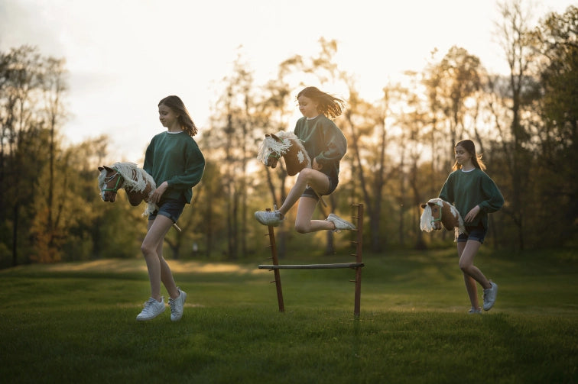

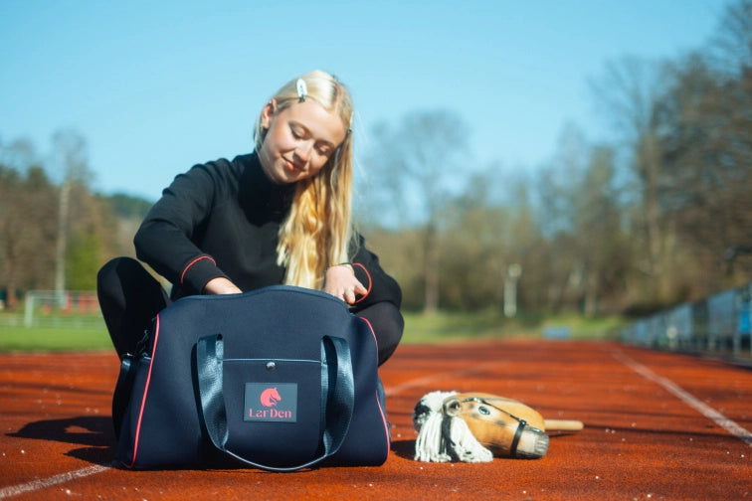

**The Right Starter Gear**

* **Hobby Horse (stick horse)** — You don’t need a professional model to begin. A simple horse that feels good in hand and that your child likes is enough. Just like with any activity, it’s important to discover what truly suits the new rider.  
  For most new riders we recommend a **versatile size S** Hobby Horse — comfy, practical, and ideal for first trainings.  
  Want details about sizes and how to choose? Read our guide: [How to choose the right Hobby Horse size](https://www.hobby-horse.com/blogs/blog/how-to-choose-the-right-size-of-a-hobby-horse).
* **Clothing & shoes** — Comfortable clothing and good sports shoes are essential. Hobby Horsing is most similar to athletics. Choose lightweight shoes with a firm sole to prevent ankle sprains.  
  Clothing should fit close to the body — wide shirts or pants can catch on the stick and cause imbalance. For an easy start, check out our [LarDen Sport Collection](https://www.hobby-horse.com/collections/equipment-for-riders).
* **Accessories** — The key accessories are a [halter](https://www.hobby-horse.com/collections/halters) with matching [reins](https://www.hobby-horse.com/collections/reins), or a full bridle with reins. Add-ons like [protective covers](https://www.hobby-horse.com/collections/protective-suit) or [blankets](https://www.hobby-horse.com/collections/blankets) keep your horse clean and ready for action.

**Clubs and Groups**

Hobby Horsing clubs and training groups work much like riding clubs, except that the stars here are Hobby Horses instead of real ones. Thanks to growing interest, there are now groups in **many towns and communities**.

Training is often led by experienced leaders or older riders who help younger members improve technique and presentation. Besides regular meetups, groups often join **competitions**, organize **day camps**, or weekend activities.

Organizations such as the **UK Hobby Horse Association** connect clubs, support the community, and help organize larger tournaments, workshops, and training camps. Thanks to these structures, Hobby Horsing is steadily becoming a **regular sport**.

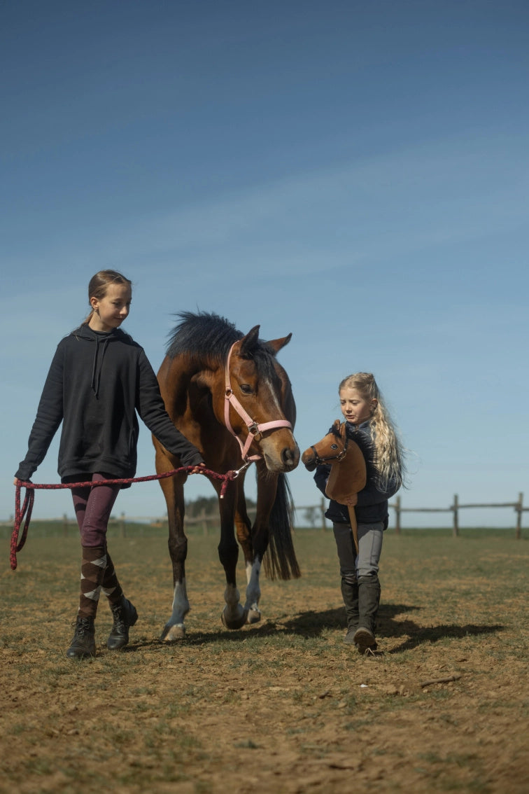

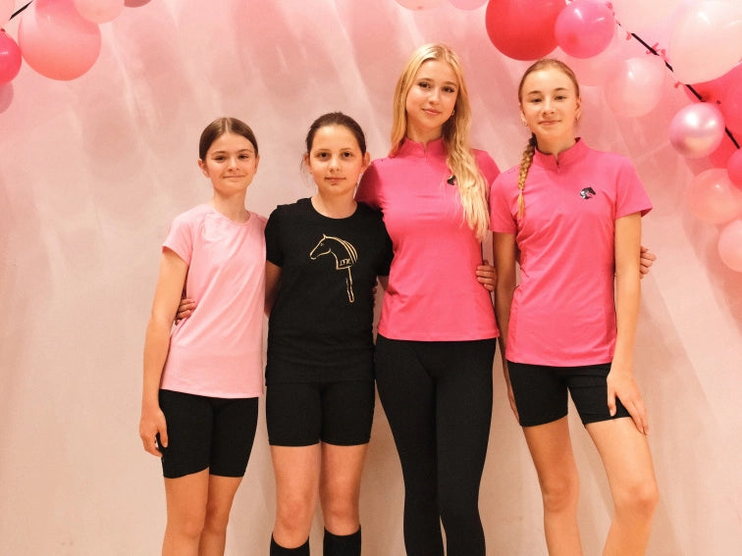

**The Power of Community**

Hobby Horsing is more than sport, training, or competition. It’s a **community** of people who share the same passion, creativity, and joy of movement. That community turns stick horses into something much bigger.

Children meet as enthusiastic riders and adults as coaches — all with a shared goal. What unites everyone is **mutual support and friendship**. At events and trainings you can feel the energy right away: smiles, cheers, tips, and learning together.

The Hobby Horsing community welcomes anyone who enjoys movement, creativity, and team spirit. Whether you’re just starting out or already have a whole “stable” at home, what matters most is passion and an open heart.

That’s the real magic of Hobby Horsing — a small but wonderfully warm community. ❤️

**Our Recommendation**

There are many ways to start with Hobby Horsing. If you didn’t find a specific answer here, feel free to reach out — the **LarDen team** is happy to help. Our five-year journey through the **world of Hobby Horsing** began in the very early days of the movement in Europe. That’s why we can say with confidence: we know this sport inside out and love sharing our experience with you. 🐴✨

What is hobby horsing? 08/01/2026 <https://www.redpostequestrian.co.uk/blog/the-rise-of-hobby-horsing-a-new-equestrian-trend/>

**What is Hobby Horsing?**

Hobby horsing involves using a handcrafted or commercial stick horse to simulate real riding. Participants perform dressage, show jumping, and even cross-country, all while holding their hobbyhorse between their legs. It combines athletic ability with imagination, making it a brilliant way for children and young riders to engage with equestrian sport.

At Redpost Equestrian, we stock a full range of **LeMieux Hobby Horses**, known for their quality and lifelike design. Whether you’re just starting or looking to level up your collection, we have the perfect hobby horse for you.

**The Origins of Hobby Horsing**

This phenomenon began in Finland over a decade ago, where young riders sought a way to express their passion outside traditional stables. Since then, hobby horsing has grown into a global trend, with competitions, clubs, and online communities flourishing.

Much like real riding, hobbyhorsing requires dedication and training. Riders choreograph routines, practice jumping, and even care for their horses as if they were real. At Redpost, we celebrate that dedication by offering **hobby horse accessories** such as rugs, fly veils, and grooming tools.

**[Shop all Hobby Horse Accessories at Redpost Equestrian](https://www.redpostequestrian.co.uk/gifts/toys--and--games/hobby-horses--accessories" \t "_blank)**

**Why Are Hobby Horses So Popular?**

Hobby horsing is inclusive and accessible. Not everyone has access to a pony, but a hobbyhorse offers a gateway into the equestrian world. It promotes physical exercise, boosts confidence, and sparks creativity. It also builds community—both online and at local events.

This movement is especially popular among children, teens, and families who want to share in the joy of horse riding without the high costs. Redpost Equestrian is proud to support this trend by providing affordable, high-quality hobby horses and gear.

**The Benefits of Hobby Horses for Young Riders**

* **Physical Activity**: Jumping and dancing with a hobbyhorse improves coordination and fitness.
* **Creativity**: Riders design their own costumes and routines.
* **Confidence**: Competing or performing builds public speaking and performance skills.
* **Friendship**: Hobby horsing encourages connection with fellow riders, just like pony clubs.

We see these benefits every day in our customers, and we’re proud to help them thrive.

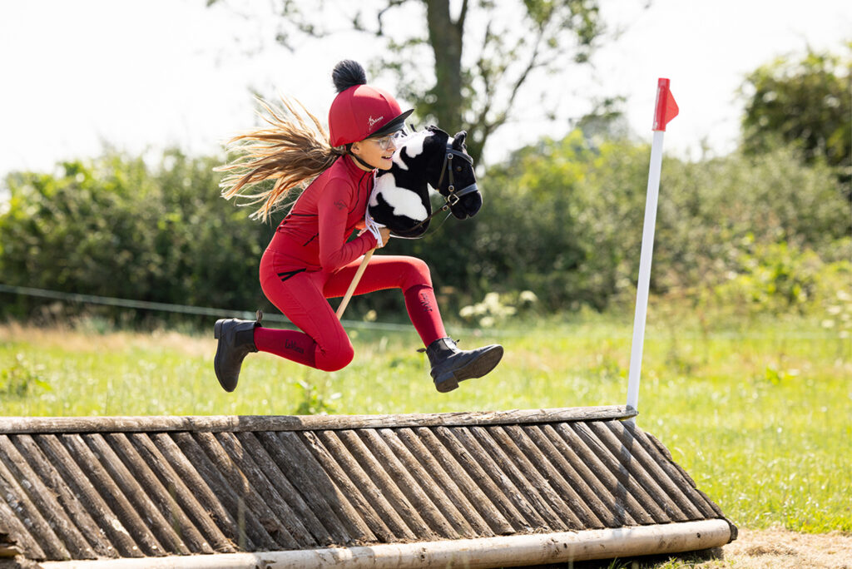

**What You’ll Need to Get Started**

Redpost Equestrian is your go-to destination for all things hobby horsing. We stock an extensive collection designed to inspire, equip, and delight.

**1. Choose Your Hobby Horses**

**LeMieux Hobby Horses**

Our **LeMieux Hobby Horses** come in a variety of breeds, colours, and sizes. Whether you’re after a majestic grey or a cheeky bay, there’s a hobbyhorse waiting for you.

Each LeMieux horse features a soft, brushable mane and a solid stick base for easy riding. They’re perfect for play, practice, or display.

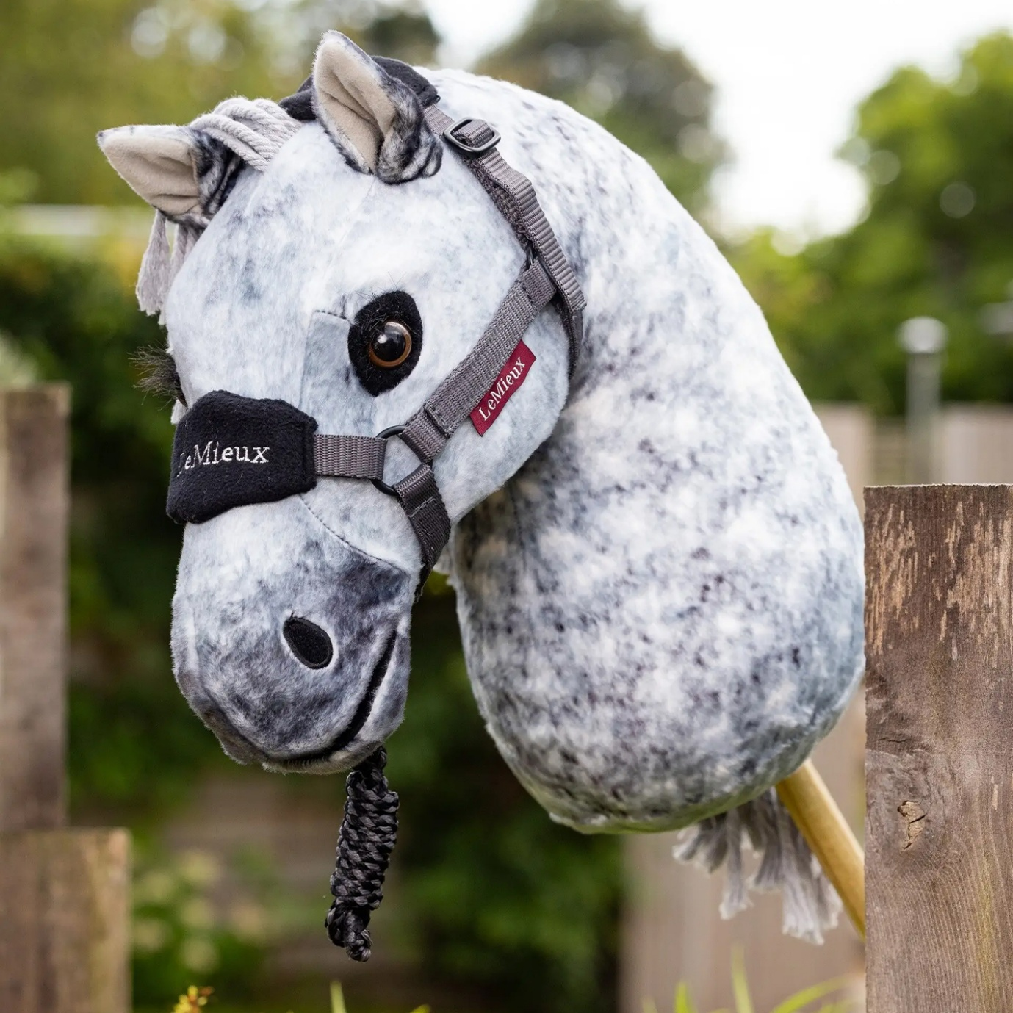[Sam](https://www.redpostequestrian.co.uk/gifts/toys-games/lemieux-hobby-horse-toy--sam__216399)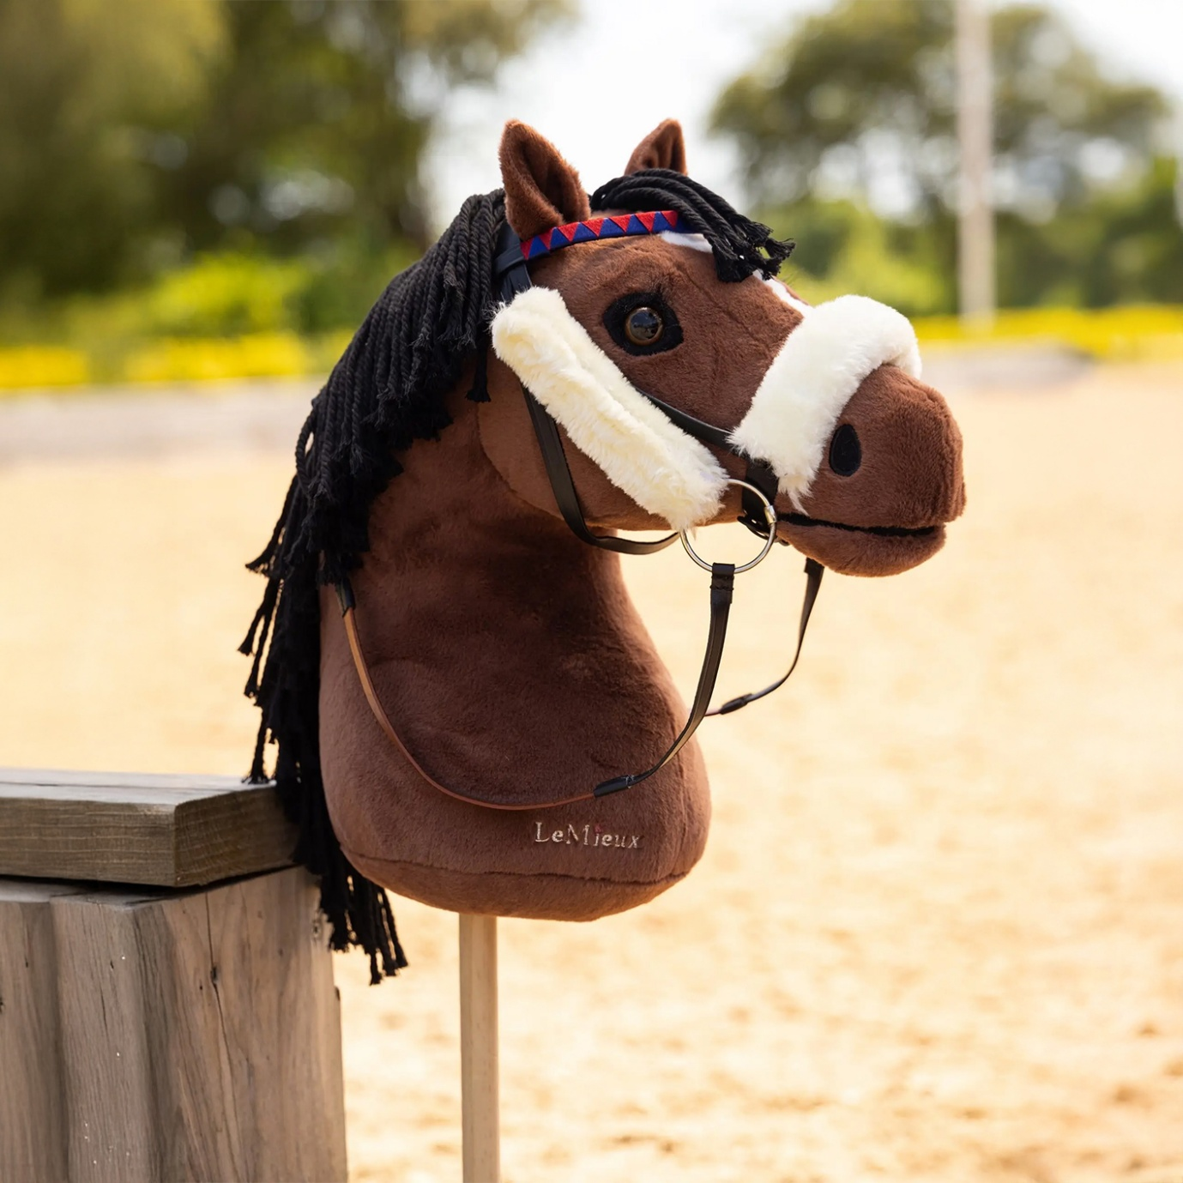[Chancer The Racehorse](https://www.redpostequestrian.co.uk/gifts/toys-games/lemieux-hobby-horse-toy--chancer-the-racehorse__219524)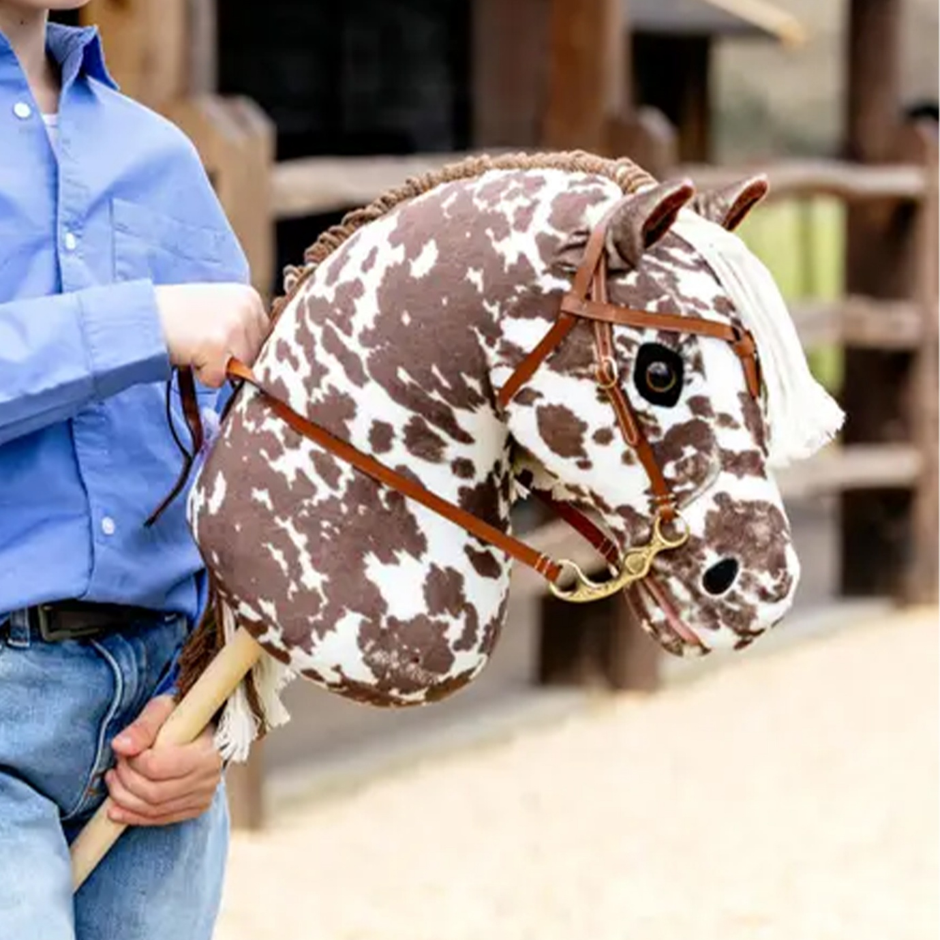[Montana](https://www.redpostequestrian.co.uk/gifts/toys-games/lemieux-hobby-horse-toy--montana__230025)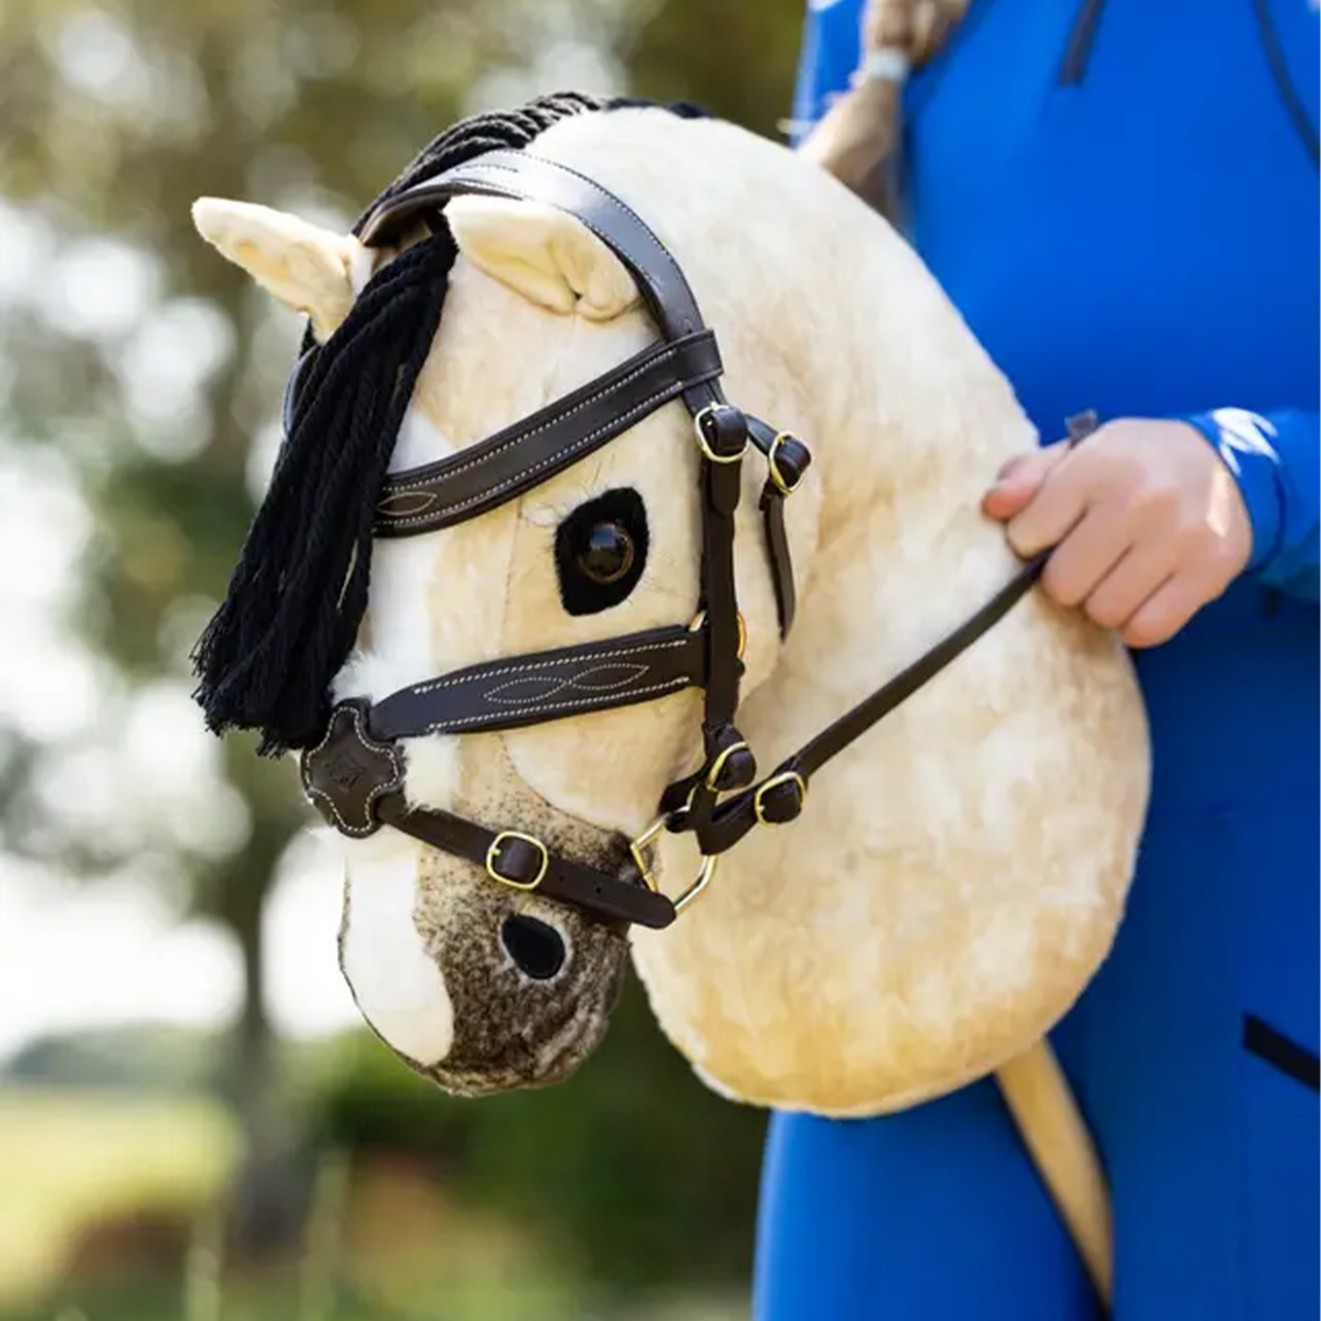[Dream](https://www.redpostequestrian.co.uk/gifts/toys-games/lemieux-hobby-horse-toy--dream__225213)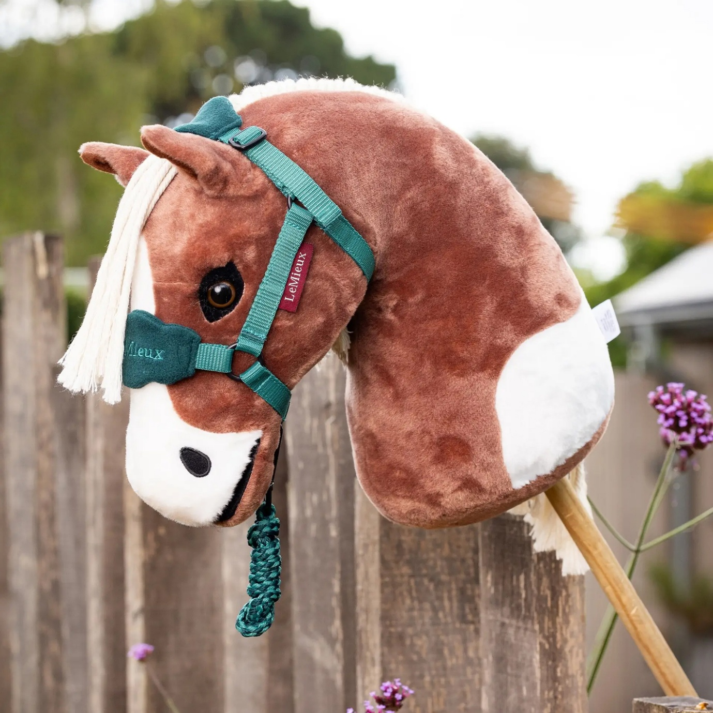[Flash](https://www.redpostequestrian.co.uk/gifts/toys-games/lemieux-hobby-horse-toy--flash__216389)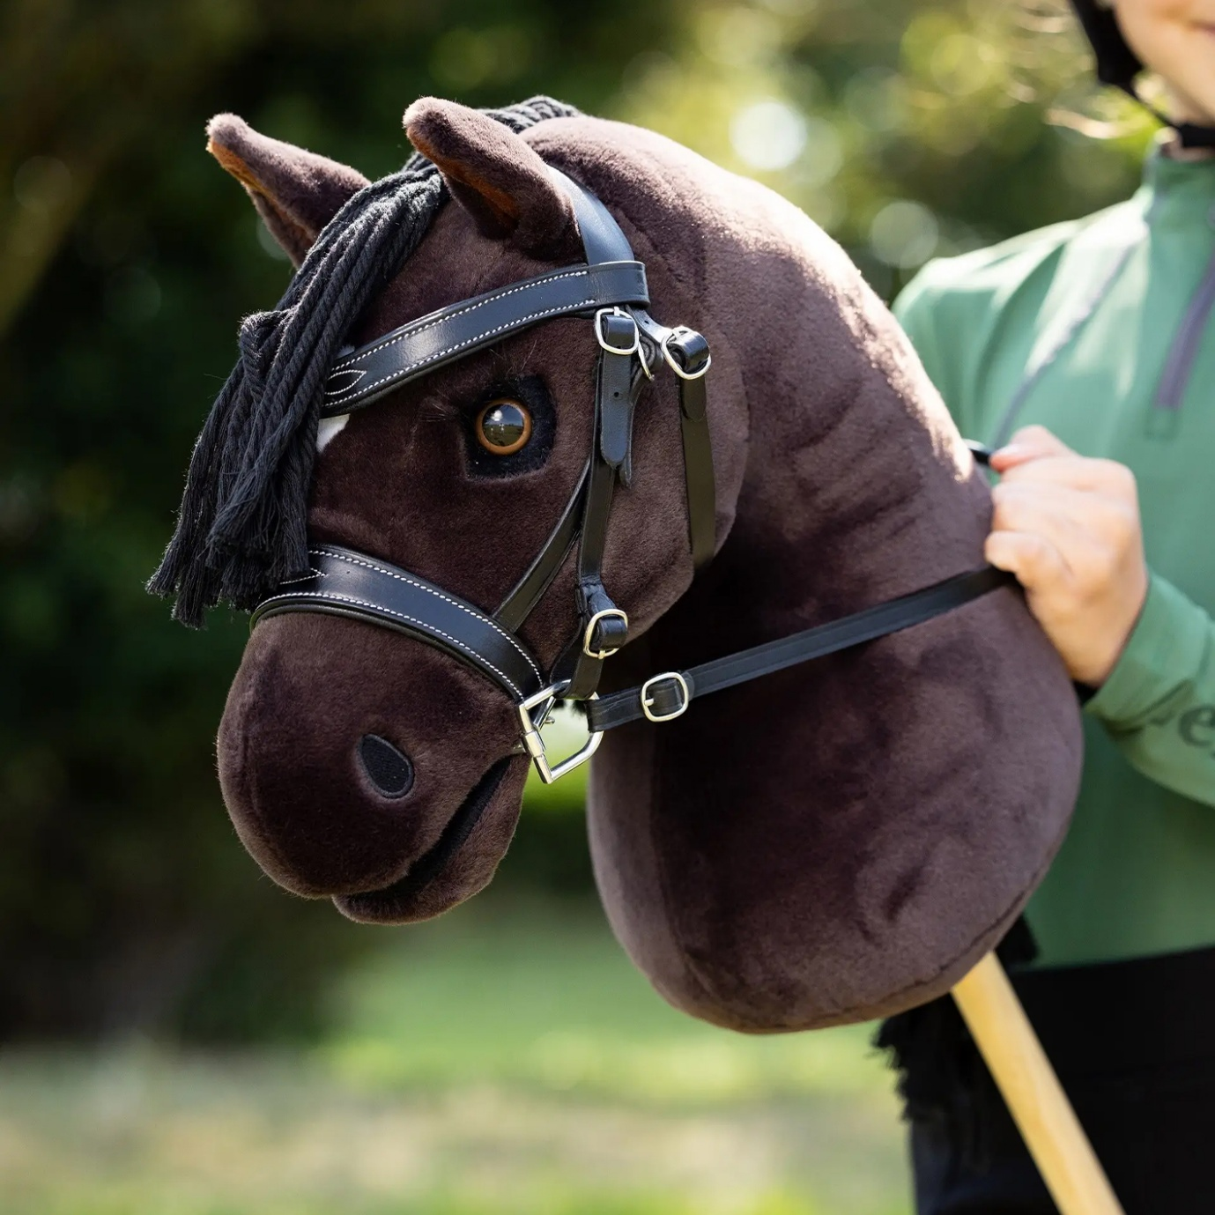[Freya](https://www.redpostequestrian.co.uk/gifts/toys-games/lemieux-hobby-horse-toy--freya__225512)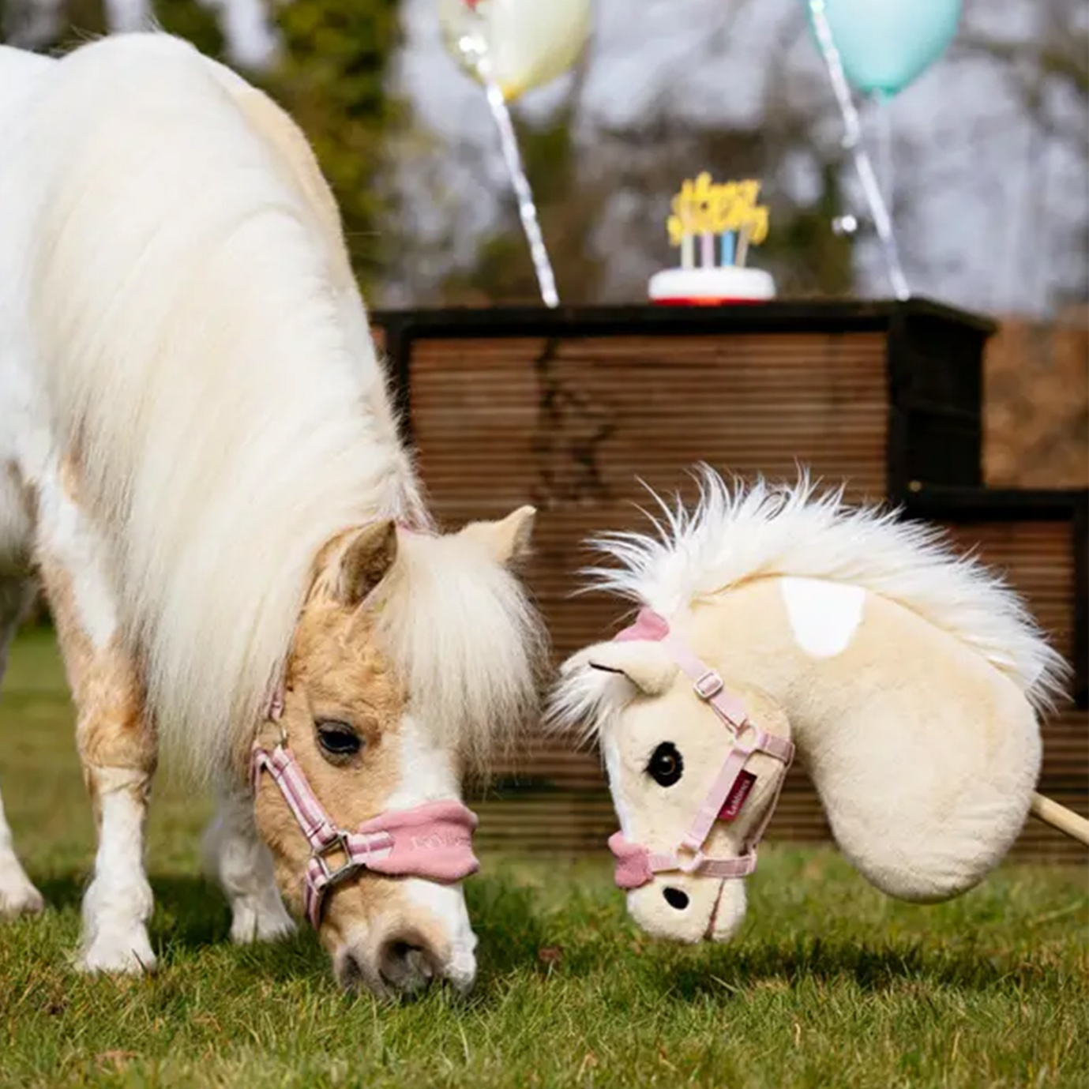[Lemon](https://www.redpostequestrian.co.uk/gifts/toys-games/lemieux-hobby-horse-toy--lemon__230024)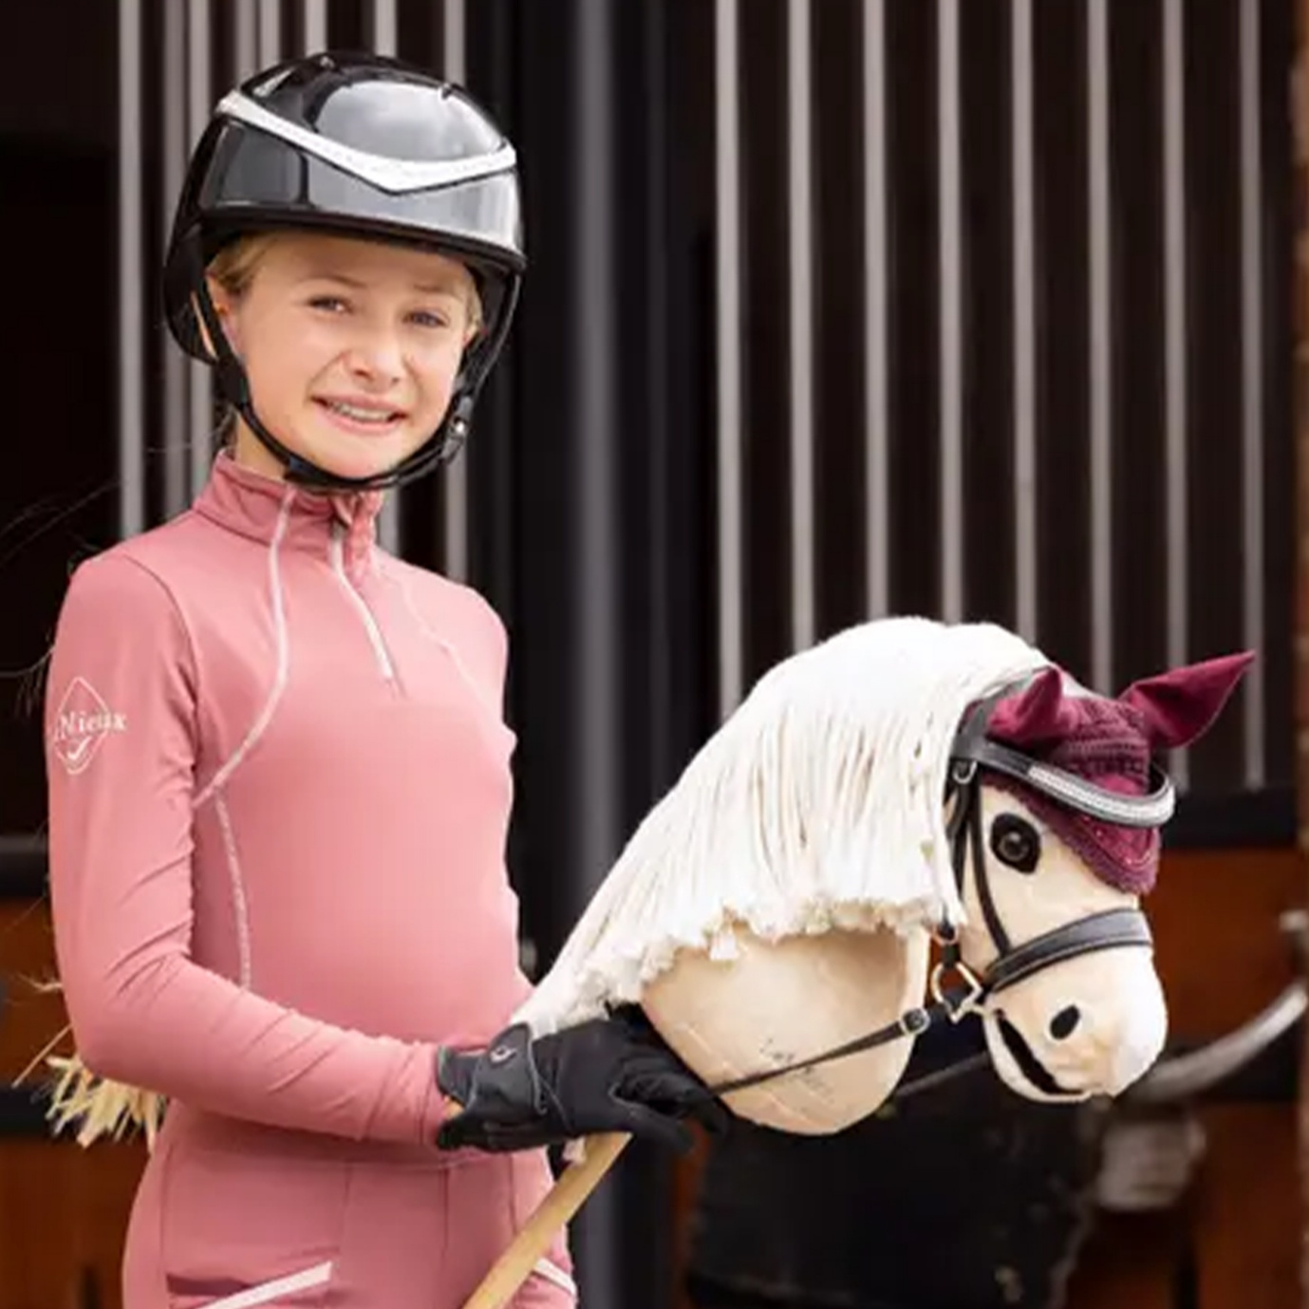[Popcorn](https://www.redpostequestrian.co.uk/gifts/toys-games/lemieux-hobby-horse-toy--popcorn__216398)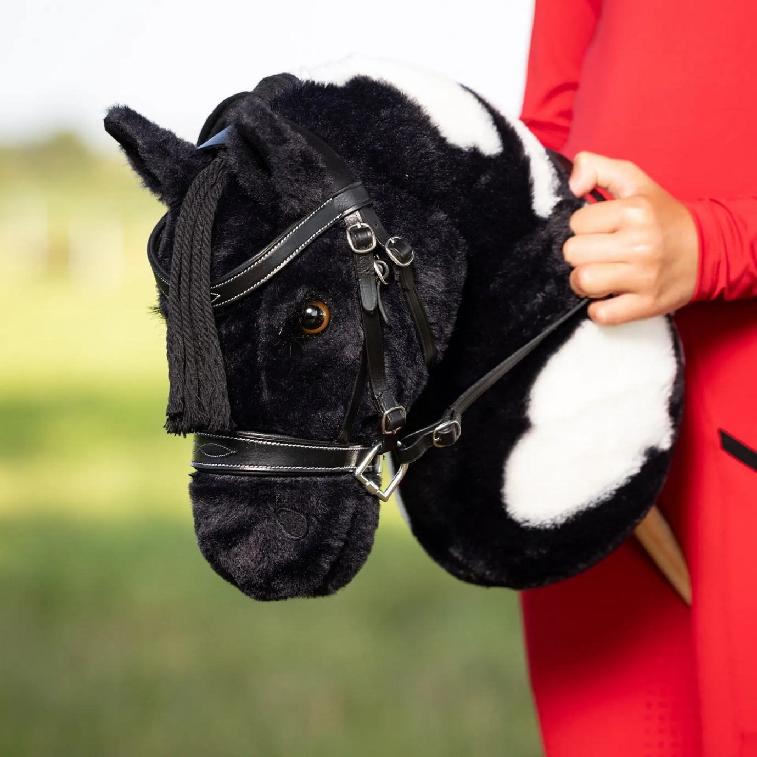[Razzle](https://www.redpostequestrian.co.uk/gifts/toys-games/lemieux-hobby-horse-toy--razzle__225486)[Sam](https://www.redpostequestrian.co.uk/gifts/toys-games/lemieux-hobby-horse-toy--sam__216399)[Chancer The Racehorse](https://www.redpostequestrian.co.uk/gifts/toys-games/lemieux-hobby-horse-toy--chancer-the-racehorse__219524)

**[Shop All LeMieux Hobby Horses](https://www.redpostequestrian.co.uk/gifts/lemieux/toys--and--games/hobby-horses--accessories" \t "_blank)**

**HKM Hobby Horses**

Get ready to gallop into fun with our adorable collection of **HKM hobby horses** at Redpost! From cuddly ponies to majestic breeds—and even a sparkly unicorn—these hobby horses are packed with personality, plush cushioned heads, and amazing lifelike details.

Black White Piebald[Light Brown Palomino](https://www.redpostequestrian.co.uk/gifts/toys-games/hkm-hobby-horse-toy--light-brown-palomino__216623)[Spotty White Appaloosa](https://www.redpostequestrian.co.uk/gifts/toys-games/hkm-hobby-horse-toy--spotty-white-appaloosa__216603)[Brown White Skewbald](https://www.redpostequestrian.co.uk/gifts/toys-games/hkm-hobby-horse-toy--brownwhite-skewbald__216636)[Grey](https://www.redpostequestrian.co.uk/gifts/toys-games/hkm-hobby-horse-toy--grey__218354)[Brown](https://www.redpostequestrian.co.uk/gifts/toys-games/hkm-hobby-horse-toy--brown__223174)[Black](https://www.redpostequestrian.co.uk/gifts/toys-games/hkm-hobby-horse-toy--black__223175)Black White Piebald[Light Brown Palomino](https://www.redpostequestrian.co.uk/gifts/toys-games/hkm-hobby-horse-toy--light-brown-palomino__216623)

There are even premium options with attachable tails for more realistic characteristics and wheeled options for tiny trotters, perfect for toddlers just starting their hobby horsing adventure!

[HKM Hobby Horses With Tails – Norwegian](https://www.redpostequestrian.co.uk/gifts/toys-games/hkm-premium-hobby-horse--norwegian__227414)[HKM Hobby Horses With Wheels – Bay](https://www.redpostequestrian.co.uk/gifts/toys-games/hkm-bella-hobby-horse-with-wheels--bay__216600)[HKM Hobby Horses With Wheels – Palomino](https://www.redpostequestrian.co.uk/gifts/toys-games/hkm-bella-hobby-horse-with-wheels--palomino__216601)[HKM Hobby Horses With Wheels – Black](https://www.redpostequestrian.co.uk/gifts/toys-games/hkm-bella-hobby-horse-with-wheels--black__216602)[HKM Hobby Horses With Wheels – Unicorn](https://www.redpostequestrian.co.uk/gifts/toys-games/hkm-bella-hobby-horse-with-wheels--grey-unicorn__216599)[HKM Hobby Horses With Tails – Buckshin](https://www.redpostequestrian.co.uk/gifts/toys-games/hkm-premium-hobby-horse--buckskin__227417)[HKM Hobby Horses With Tails – Chestnut](https://www.redpostequestrian.co.uk/gifts/toys-games/hkm-premium-hobby-horse--chestnut__227418)[HKM Hobby Horses With Tails – Norwegian](https://www.redpostequestrian.co.uk/gifts/toys-games/hkm-premium-hobby-horse--norwegian__227414)[HKM Hobby Horses With Wheels – Bay](https://www.redpostequestrian.co.uk/gifts/toys-games/hkm-bella-hobby-horse-with-wheels--bay__216600)

**[Shop All HKM Hobby Horses](https://www.redpostequestrian.co.uk/gifts/hkm/toys--and--games/hobby-horses--accessories" \t "_blank)**

**Imperial Riding Hobby Horses**

Let the fun begin with our fabulous range of Imperial Riding Free Spirit hobby horses at Redpost—perfect for little riders just starting out! With super bushy manes ideal for grooming, built-in bridles for realistic play, and a variety of charming breeds, these well-crafted hobby horses are made for magical adventures around the house or garden.

[Imperial Riding Bay Hobby Horses](https://www.redpostequestrian.co.uk/gifts/toys-games/imperial-riding-free-spirit-hobby-horse--dark-brown-bay__227686)[Imperial Riding Palomino Hobby Horses](https://www.redpostequestrian.co.uk/gifts/toys-games/imperial-riding-free-spirit-hobby-horse--palomino-beige__227685)[Imperial Riding Bay Hobby Horses](https://www.redpostequestrian.co.uk/gifts/toys-games/imperial-riding-free-spirit-hobby-horse--dark-brown-bay__227686)[Imperial Riding Palomino Hobby Horses](https://www.redpostequestrian.co.uk/gifts/toys-games/imperial-riding-free-spirit-hobby-horse--palomino-beige__227685)

**[Shop All Imperial Riding Hobby Horses](https://www.redpostequestrian.co.uk/gifts/imperial-riding/toys--and--games/hobby-horses--accessories" \t "_blank)**

**2. Accessorise Your Hobby Horses**

Just like real ponies, hobbyhorses deserve stylish accessories:

* **Hobby Horse Rugs** – Available in seasonal colours, perfect for chilly days or competitions.
* **Fly Veils** – Keep your hobbyhorse competition-ready with matching ear bonnets.
* **Headcollars and Lead Ropes** – Essential for grooming time and groundwork practice.
* **Grooming Kits** – Designed for little hands, these include brushes and combs tailored to your LeMieux horse’s mane and tail.

All these essentials can be found at Redpost, where our selection grows as the sport does.

**3. Build Your Hobby Horses Arena**

To simulate the real equestrian experience, many hobby horsers create arenas in gardens or at local clubs. Redpost stocks **Hobby Horse Jumps** perfect for at-home training or group competitions.

These jumps are adjustable and lightweight, designed with young riders in mind. Whether you’re clearing a cross pole or aiming for a higher round, our jumps support every goal.

Looking for well-designed and high-performing Hobby Horse Jumps? Discover our brand new and exclusive Redpost Hobby Horse Jumps—handcrafted locally with care and creativity to elevate your hobby horsing experience. Whether you’re just starting out or aiming to take your skills to the next level, our jumps are designed to help you train like a pro while having serious fun.

**[Shop Redpost Hobby Horse Jumps HERE!](https://www.redpostequestrian.co.uk/gifts/redpost/toys--and--games/hobby-horses--accessories" \t "_blank)**

**How to Get Involved**

Joining the hobby horsing world is easy. Here’s how:

* **Start Practicing**: Use your garden or a local park to practice jumps, dressage routines, and groundwork.
* **Join a Club**: Look for local hobby horse groups or ask around at your riding school.
* **Attend Events**: From fun days to formal competitions, events are popping up across the UK.
* **Follow the Trend**: Social media is filled with hobby horsing inspiration, tutorials, and friends to connect with.

And, of course, you can visit **Redpost Equestrian online or in-store** for all your hobby horsing needs.

**Hobby Horses vs Traditional Riding**

Hobby horsing doesn’t aim to replace real horse riding—it complements it. Many young equestrians use hobby horses to extend their learning, improve fitness, or simply enjoy horsey fun when their real ponies are resting.

It’s a brilliant way to build horsemanship skills. Caring for a toy hobby horse, naming it, and choosing its accessories teaches responsibility and planning—just like pony ownership.

At Redpost, we love how the two worlds support each other. That’s why we’ve made it easy to shop for both, all in one place.

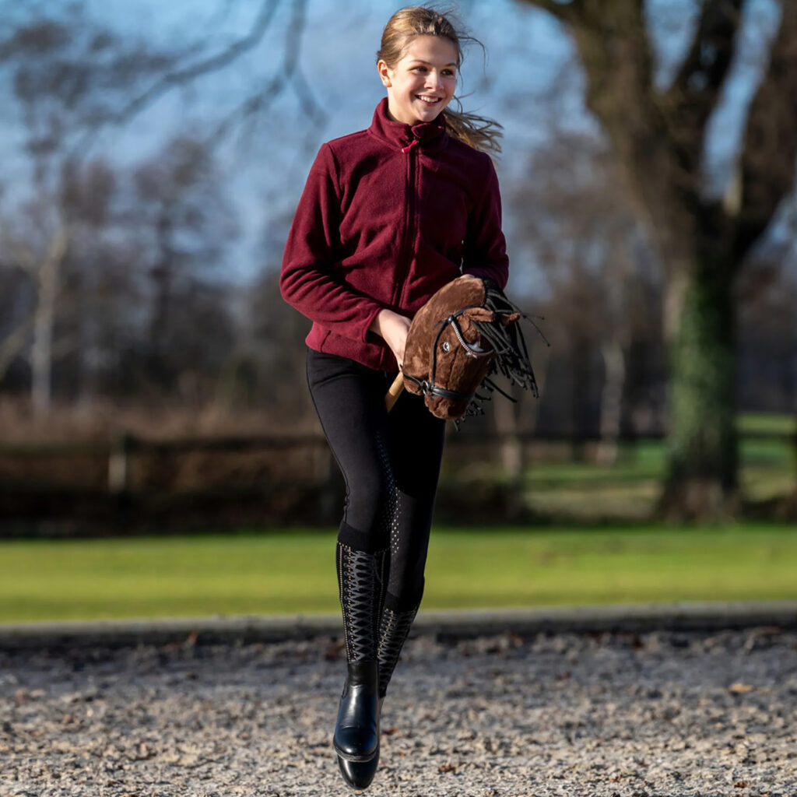

**Why Choose Redpost Equestrian?**

We’re more than just a store—we’re a part of your equestrian journey. When it comes to hobby horsing, Redpost offers:

* A wide selection of **LeMieux Hobby Horses** and accessories.
* High-quality **hobby horse jumps** and grooming tools.
* You will receive friendly, knowledgeable advice from fellow horse lovers.
* Fast, reliable delivery and excellent customer care.

**Final Thoughts**

Hobby horsing is fun, empowering, and full of possibility. It introduces young riders to a world of movement, imagination, and joy—without the need for a real horse. At Redpost Equestrian, we proudly support this creative equestrian sport by offering everything you need to get started.

So, why wait? Explore our collection of **hobby horses**, accessories, and more today, and let your hobby horsing adventure begin!

Show off your favourite hobby horsing accessories on our socials and share your fun equestrian moments with us!

Horsey Counsel – Louise Richards 08/01/2025

<https://horseycounsel.com/what-is-hobby-horsing/>

**What Is Hobby Horsing and What Are Its Main Competitions?**

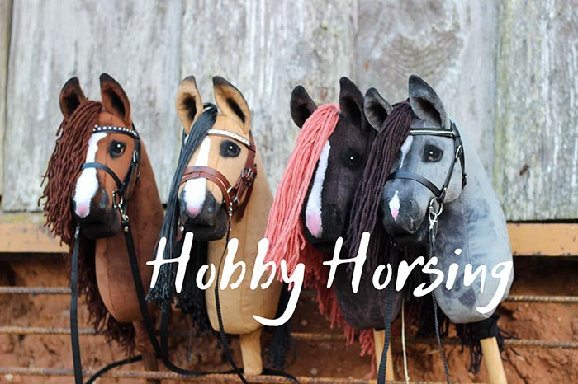Image courtesy of HOBU Hobby Horses

I know we generally only talk about real horses here on HorseyCounsel but I wanted to touch on a slightly different yet related subject today. That’s right, today we’re going to talk about hobby horsing, and by the end of this article, you should know everything there is to know about this sport. **Hobbyhorsing is officially accepted as an organized**[**sport**](https://horseycounsel.com/popular-horse-sports/)**in most parts of the Western world**, and it is definitely growing in popularity. But what exactly is it?

Basically, **hobby horsing involves riding artificial (man-made) horse heads placed on a stick**. Riding stick horses might not be as glamorous or as popular as riding real horses, but it does have its charm and its advantages. One of the main reasons why hobby horsing has become so popular in the first place is because it offers a cheaper alternative to real horseback riding. It might look like “playing pretend” but it is undeniably fun, and it’s good exercise.

**Hobby horsing is mainly practiced by teenage girls or girls aged between 10 and 18**. However, there are no rules preventing boys from participating, and quite a few of them have started to enroll in competitions in the last few years.

**Hobby horsing origins.**

Hobby horsing first kicked off in Finland in 2012, but the exact founders of the sport are currently unknown. That’s because this equestrian trend was being practiced in secret for a long time before it actually became popular nationwide. In Finland, hobby horsing is officially recognized as a sport and it has more than 10,000 fans.

While not as popular as in Finland, the sport also has a decent fan base in the USA, and in Australia. As with most sports, there are several different hobby horsing divisions, and each competition has its own strict set of rules.

**Hobby horse competitions.**

You might be wondering by now: how exactly do you compete with a hobby horse? Well, these competitions are quite similar to those involving real horses. This means that the rules are similar and that there are judges involved. Participants need to perform a series of stunts such as jumping over obstacles, but they are also judged on their gaits, posture, running style, the hobby horse itself, and overall energy.

As for divisions, hobby horsing dressage is one of the most popular ones, especially since it includes three different levels: beginner, intermediate, and advanced. The jump heights depend on the contestant’s age.

Beginners are required to perform 6 to 8 movements including various gaits such as walk, canter, and trot. They might also perform movements such as loops, reverse loops, turns, and half-turns.

Intermediates usually perform 8 to 10 movements that include the beginner ones as well as extended gaits, half passes, and flying charges.

Advanced hobby horse competitors perform 10 to 12 movements that include tempi changes, passages, zig-zag turns, and half passes. They must also complete the beginner and intermediate levels as well. If successful, these competitors can consider themselves hobby horsing professionals.

**What are the rules?**

It’s important to note that hobby-horsing competitions are not governed by an official body. Therefore, they’re not subject to an official regulatory set. However, there are a few general rules that need to be respected by all competitors:

* Competitors should wear a helmet while they perform. Proper attire is also preferable.
* They are not allowed to bring pets to the premises.
* They are not allowed to bring or consume drugs or alcohol on the premises.
* All competitors must wear proper running shoes.
* The hobby horses need to be in good condition and look presentable. Hobby horses with short sticks are preferred.
* Each participant must perform within their allocated timeframe.
* Judges always have the final say.

**Hobby Horsing in the United States.**

We now know that this equestrian trend was founded in Finland by a group of teenage girls. However, how did it spread to the United States and how big is its fan base right now? Again since the sport is not governed by an official entity, it’s difficult to figure out exactly how many people participate in the events, or how many view them live or online.

What I can tell you is that there are currently numerous hobby horse competitions scheduled for this year and the next, including the ones in White Oak Stables, WinWinEquine near Atalanta, and Tryon in North Carolina, which hosted the inaugural American Hobby Horse competition.

Whether used for competitions or recreation, there are also numerous hobby horses available for sale at retailers such as Amazon. This shows a real interest in the activity, and I think it will definitely catch on even more as time goes by. At the end of the day, the United States is vast, as hobby horsing isn’t going to be as popular everywhere.

There are certain pockets of the country that are showing an increased interest in the sport, particularly in the South.

**Do you need to own a horse to participate in hobby horsing tournaments?**

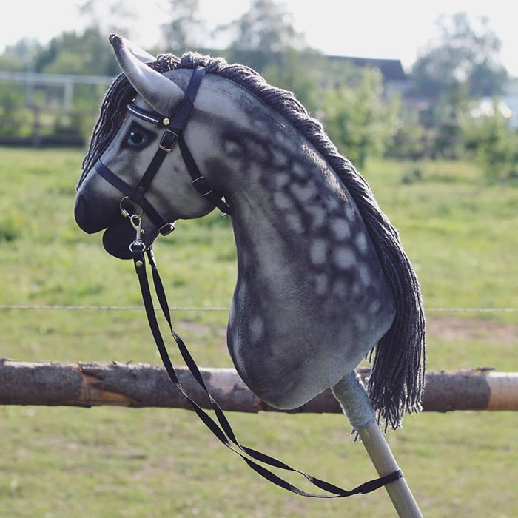

Owning a real horse is not mandatory, as it wouldn’t offer a real advantage anyway. If you do own a horse and you want to take part in such a competition, you’re free to do so. You’ll likely be more in-tune with the equestrian world, and you might be able to understand the rules quicker. However, you won’t be able to bring your horse with you to the grounds, and you won’t be able to rely on your horse riding skills for an edge.

**Is hobby horsing in the Olympics?**

Hobby horsing is not part of the Olympic Games just yet, but it has been proposed for inclusion in the Paris 2024 Olympics according to the FEI. The popular Finnish sport would strive for acceptance alongside skateboarding, breakdancing, and surfing.

If accepted, hobbyhorse riders would compete for team and individual medals in the three main current Olympic disciplines, namely Jumping, Dressage, and Eventing.

**What about the name?**

When it comes to naming this unique equestrian activity, it looks like things are rather straightforward. The people who invented this sport were riding their stick horses for fun and leisure, and it soon became a hobby that they wanted to share with the entire world. Hobby Horsing is riding a toy horse as a hobby.

It’s not as serious as owning and caring for an actual horse, but it’s still something you can dedicate a large portion of your time to.

**How much does a hobby horse cost?**

Hobby horses or stick horses for children cost anywhere between $40 and $150 on average, but stick horses to be used in competitions can end up costing as much as $1000 or even more. The price is dictated by how good the hobby horse looks, but also by the materials used in its construction. The size of the toy plays a big part as well, including the length of the stick.

Generally speaking, these are not the most expensive toys you can get your hands on, but you can still save a few bucks by making one yourself. You’ll find a complete guide below if you’re interested.

**Can I make my own hobby horse?**

Yes, you can, and it’s not even that hard to do if you have all the right materials. Keep in mind that your hobby horse will need to look presentable for the competition, so you’ll likely need to do a decent job. If you don’t want to spend money on a brand new one from the store, you can always buy a used one, or make one yourself. Obviously, creating your own hobby horse is the most difficult path, but it can also be the most rewarding since you’ll have a better bond with that stick horse.

**Here’s what you need to create your own hobby horse:**

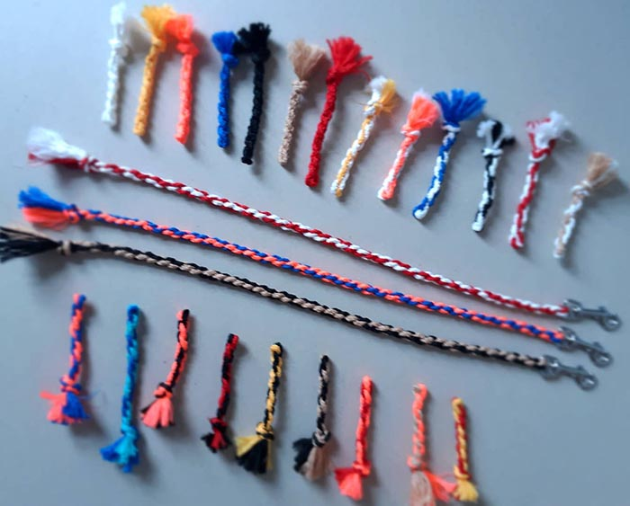

* A needle and thread or a sewing machine.
* Scissors.
* Some fabric for your horse’s head (preferably brown, black, white, or beige)
* A stick horse head template.
* A stick.
* Pellon pieces that you’ll use for the ears.
* 1/2 inch wide ribbon (around 5 feet).
* 2 metallic buttons and 2 buttons for the eyes.
* A stuffing wire-bristle brush.
* A hot glue gun or some fabric glue.

**How to make a hobby horse:**

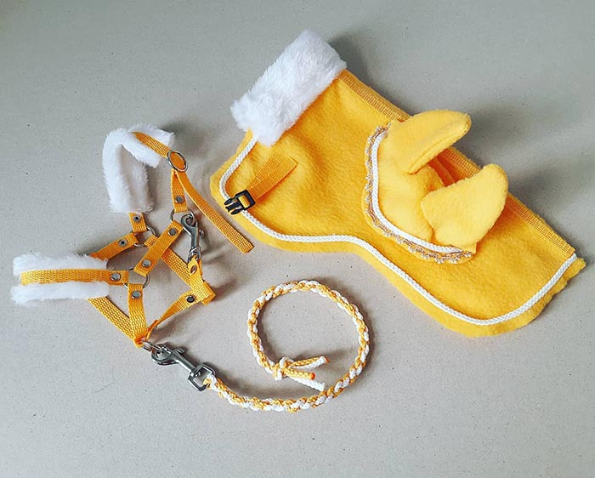

* The first thing you need to do is to **cut out a horse face stencil or template**. You can use that template to cut your cloth in the shape of a horse’s face. You’ll need two cloth horse faces for your hobby horse – one for each side.
* Now use the same fabric and **cut out a rectangle**. You’ll use it to **join the two horse faces** by sewing them together while leaving the bottom part open.
* **Cut a slit** in the side of a horse’s neck. Then, **stitch the yarn threads**.
* **Put the stitching inside the horse’s face** by flipping its insides. Continue to put stuffing in the horse’s face.
* Stitch two buttons as **eyes**.
* Cut four triangles from the Pellon pieces, stick two of them together, and **place them as ears** on the top of the head.
* Place various pieces of ribbon around the face and mouth of your stick horse.
* **Equip the reins** – a rope with buttons will do just fine.
* **Place the stick inside the stuffing** and seal it tightly with glue.

**Conclusion.**

Now you know exactly what hobbyhorsing is, where it came from, and what we can expect from it in the future. If you would like to pursue this activity yourself in your spare time, you now have all the information you need to do so. If you have anything that you would like to share from your own experiences riding stick horses, don’t hesitate to get in touch!

All the images in this article were sourced from [HOBU Hobby Horses](https://www.facebook.com/hobuhobbyhorses/) – a handmade hobby horse maker in Estonia.